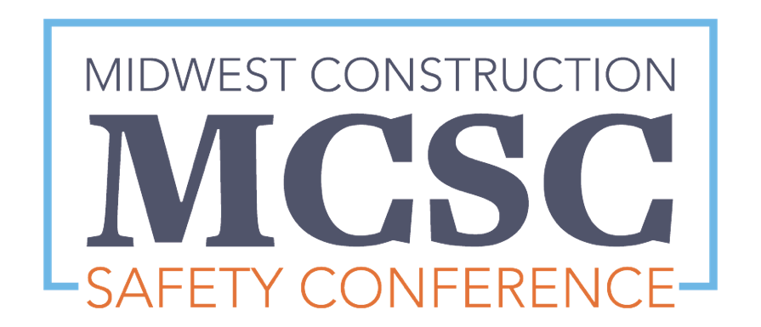
  - MCSC | March 7 and 8, 2024

Vendor opportunities
The Midwest Construction Safety Conference is committed to improving construction safety throughout the region with top-tier education from safety experts across the construction industry. The conference and expo will take place March 7 and 8, 2024, at Adams Pointe Conference Center in Blue Springs, Missouri.
The MCSC Advisory Board would like to invite your organization to be part of this exciting event by becoming a vendor. Please take a moment to review the vendor information below.

Vendor booth details
Each vendor booth includes three meals, breaks and networking reception for two (2) workers per booth, a booth space of your choice (on a first-come, first-served basis), a back drop, two side drops, one skirted table, two chairs, waste basket, personalized ID sign, free Wi-Fi, access to 110 volt electricity at the additional cost of $20 per booth, company name, logo and contact information listed on promotional material and company logo displayed during breaks.
A layout of the vendor booths is included on the last page of this document. Please indicate your booth preference first choice, second choice and third choice. (If first choice is not available, we will then refer to second and third choices.) The booths will be assigned on a first-come, first-paid basis and will be confirmed by email after payment is received and the booth has been assigned.
Interested? Contact Morgan Morrison to secure your booth.

Vendor booth options
Qty | Item |  |  |  | Price
 | Early bird single booth  (before Jan. 1, 2024) | 1st choice | 2nd choice | 3rd choice | $460
 | Early bird multiple booths  (before Jan. 1, 2024) | 1st choice | 2nd choice | 3rd choice | $440
 | Single booth  (after Jan. 1, 2024) | 1st choice | 2nd choice | 3rd choice | $510
 | Multiple booths  (after Jan. 1, 2024) | 1st choice | 2nd choice | 3rd choice | $490
 | Electricity |  |  |  | $20
 | Additional table |  |  |  | $20
 | Additional booth worker per person fee  (includes 3 meals and breaks) |  |  |  | $135

